GPR Root Mapping System

Pre-Proposal

November 24, 2015

ECEN 403 – Capstone (Senior) Design

Texas A&M University, College Station, TX

Team 24

Coy Coburn and Michael Turner

Abstract

The purpose of this project is to design and create a device that will scan the ground and make detailed picture root systems that lie underneath. The device will transmit a signal in the range of 500 MHz to 1 GHz that will penetrate the ground from 15 inches up to one meter. The device will be able to detect differences of moisture and nutrient levels in the found root systems.

The scanner will consist of a transmitter system, a receiver system, and a display system. The transmitter and receiver will utilize the GPR method to send the signal and receive the echo back from the Earth and anything that it hits. Once the signal is received, the scanner will record and process the radio signals into digital signals and process an image of the recorded data for display to the user. Over multiple instances of running the device, the user will have enough data from the images to observe the change in the soil composition due to the actions of the root systems absorbing and transferring water and nutrients from the soil.

# INTRODUCTION

A. Need Statement

The problem this project addresses is the need to detect moisture and nutrients movement through the soil as well as plant roots. This allows for the observation and experimentation of natural ecosystems without any destruction on the actual environment. Research utilizing this project’s device can lead to improvement in farming techniques, minimizing damage to the environment from human interaction, aid in hydrogeophysics contributions, as well as quicker soil replenishment and reforestation.

B. Proposed System

The hardware that will make up the GPR root device will include a transmitter, a receiver, at least two antennas, and a control unit with subsystems of data storage and display falling under the control unit. These parts will allow for a period scanning of the Earth up to one meter and paint a detailed idea of what exactly is in the ground that users cannot see, as well as the micro transactions that are happening as well.

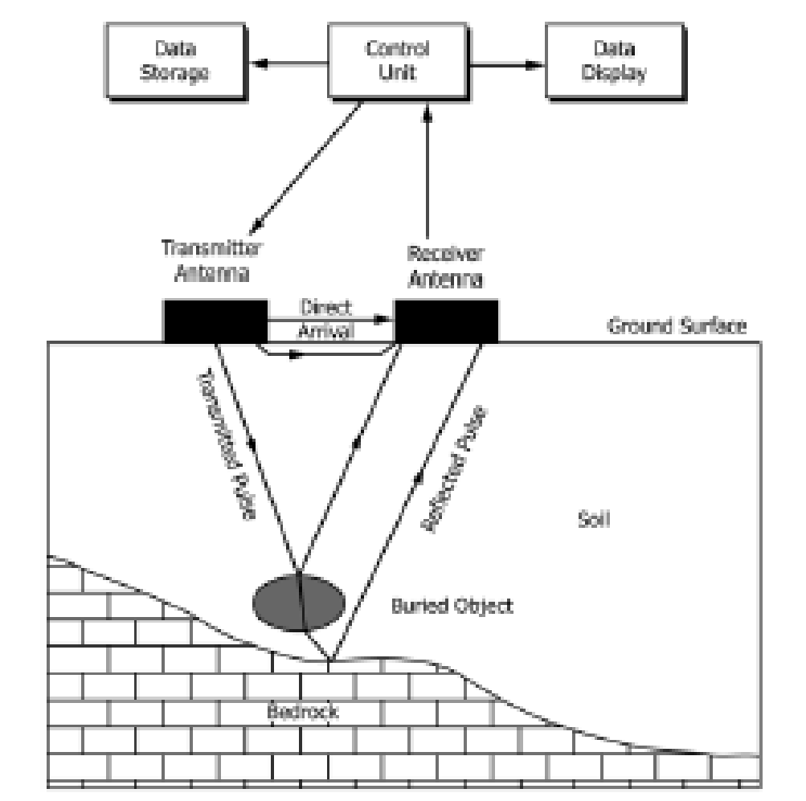

Figure 1: Block diagram of GPR system

|  |  |  |  |
| --- | --- | --- | --- |
| Material | Relative Permittivity, K | Pulse Velocities, m/Ns | Conductivity, mS/m |
| Sand (dry) | 4-6 | 0.15-0.12 | 0.0001 - 1 |
| Sand (saturated) | 25 | 0.055 | 0.1 - 1 |

Table 1: Surface material and notable attributes

GPR stands for ground penetrating RADAR and is the technique to use high-frequency pulsed EM pulses (from 10 to 3000 MHz) into the ground to discover what is underneath. The propagation of the transmitted signal depends on electrical properties of the materials that the signal is reflected off. The dielectric constants of these materials will influence the signal’s echo and will be revealed in the data collected by the receiver. GPR can be done either by continuous profiling or stationary point collection. While continuous may be quicker to cover more area, the data received is not nearly as detailed or accurate. For the project’s scope, stationary point collection will be the better choice given its method to stack scans multiple times for more accurate results before moving to the next area to be scanned.

|  |  |  |  |  |  |  |
| --- | --- | --- | --- | --- | --- | --- |
| Relative Permittivity | 1 | 5 | 10 | 15 | 25 | 80 |
| Frequencies |  |  |  |  |  |  |
| 100 MHz | 3 | 1.36 | 0.96 | 0.76 | 0.6 | 0.32 |
| 200 MHz | 1.52 | 0.68 | 0.48 | 0.4 | 0.32 | 0.16 |
| 300 MHz | 1 | 0.44 | 0.32 | 0.24 | 0.2 | 0.12 |
| 500 MHz | 0.6 | 0.28 | 0.2 | 0.16 | 0.12 | 0.08 |
| 900 MHz | 0.32 | 0.16 | 0.12 | 0.08 | 0.08 | 0.04 |

Table 2: Radar Wavelengths for Antenna Frequencies and Relative Permittivity

The receiver will convert the received echo signals into a digital signal to obtain the reflected information. The receiver with need to be sensitive, have a large fractional bandwidth, good noise performance, and a large dynamic range. The receiver hardware will include a time varying gain (TVG), a low noise amplifier (LNA), and sample and hold (S/H) circuit unit.

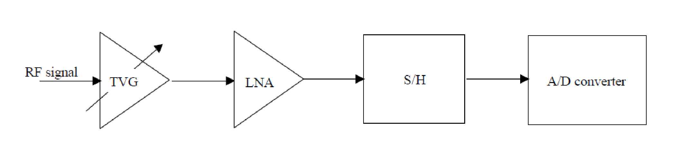

Figure 2: Block diagram of receiver

The TVG’s purpose is to compensate for spreading losses of the transmitting signal and reflected echo. This is done by introducing a fixed gain in dB per unit in time (or distance). In reality, the TVG is an attenuator based in PIN diodes that can have a variable resistance as a function of voltage. Since the first and largest reflectance is the air-ground interface, the reflections in the ground will be seen later in time and are less attenuated. This allows for the LNA following the TVG to be more sensitive and therefore increasing the range of the receiver.

The LNA conditions the entering RF signal to utilize the whole dynamic range. This is a necessity due to losses mentioned earlier in the TVG section and to ensure that most, if not all, objects in the ground are noticed and recorded in the reflected signals.

The S/H circuit unit provides a constant stable signal value for the A/D converter. The input bandwidth must be of the same order as the highest frequency received. A full-bridge sampler circuit has been chosen for its good linearity, noise performance, and common usage with frequencies under 1 GHz.

With A/D converters that have conversion rates of 200 MHz for 8 bit and 10 MHz for 16 conversions, a technique is to slow down the sampling rate. Sequential sampling can do this by converting on intersections of the slow and fast ramps, which are determined by the wanted number of samples and PRF rate. Conversions done by the actual A/D converter with 16 bits can have a dynamic range of 96 dB.

The main objective for the start of this project is to decide between the different methods of implementing the GPR system. These include the frequency modulated continuous wave (FMCW) radar and impulse GPR. FMCW radar is based on a frequency transmission that is always changing due to the VCO. A mixer is then used to mix the received echo with a waveform sample and generates an IF, which is related to the target’s range. For impulse GPR, the hardware includes ultra-wideband ground-penetrating radar (UWB GPR) transmitters, which are circuit devices capable of generating very short pulses of energy. Typical pulse durations last between 100 ps to 1 ns, while peak voltage of the transmitter can be up to 200 V. The receiver, however, is much more complex than the transmitter as seen in the earlier sections of this preproposal. The team will work with impulse the GPR due to the spectrum with the given frequency content when the time domain pulse is sent into the ground. This is a huge advantage over sending each radiated frequency individually as in FMCW.

Antennas used for transmission and receiving of radar signals are generally electric dipoles. These antennas can also be housed in single enclosure where the distance is fixed, or in two enclosures with varied distance. Varying distance can aide in optimizing the survey design for specific root structure detection.

There are also multiple choices for choosing an antenna to implement GPR. The bow-tie antenna’s radiation pattern and input impedance are manipulated by the flare angle. A shield has been introduced to designs to reduce interference due to its omni-direction on the symmetry plane. Conical and biconical antennas are frequency independent antennas. As the cone angle increases, the amplitudes of reactance fluctuation and resistance decrease. The Vivaldi antenna is also a frequency independent antenna, while also acquiring a significant gain and linear polarization. Performance depends on divergence rate, dimensions, and the substrate’s dielectric constant. The Vivaldi antenna also possesses a long electrical length compared to the physical size, as well as allowing for stacking multiple antennas in tight spaces. When implementing a phased array system, this can be beneficial for smaller designs.

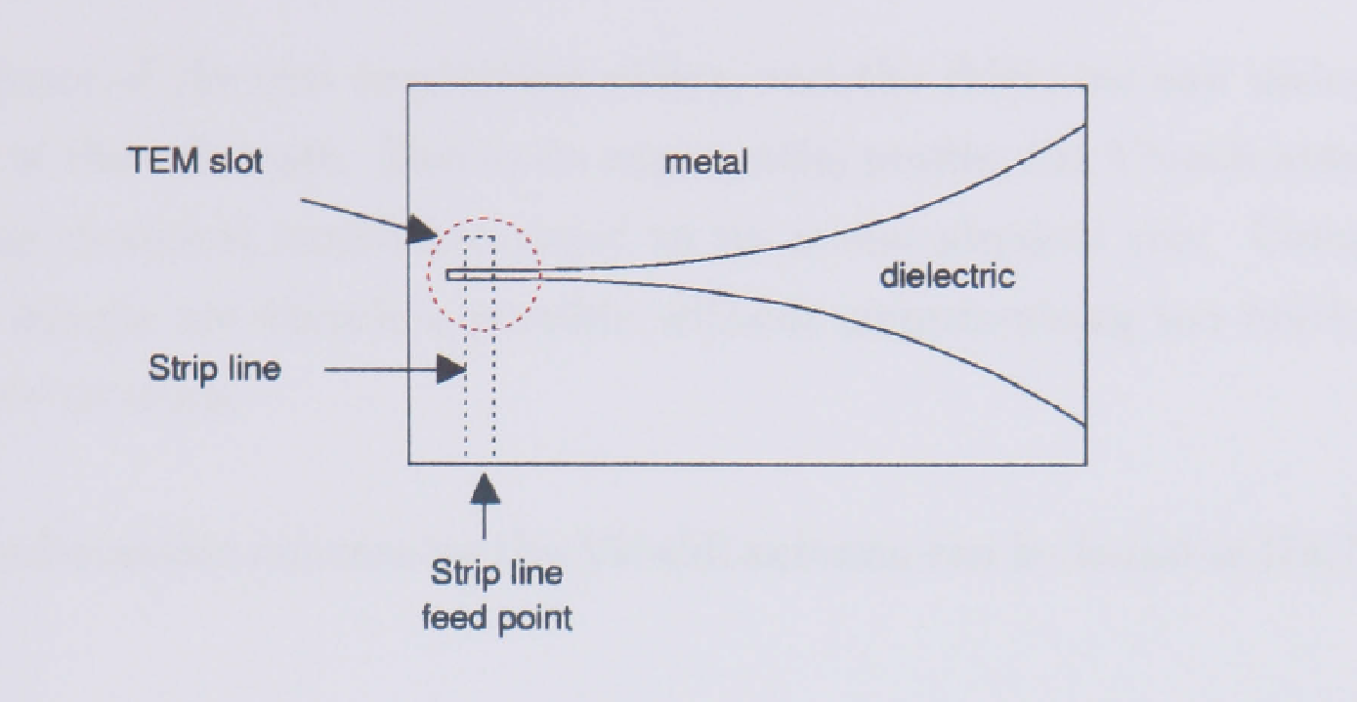

Figure 3: Vivaldi antenna design, side view

The phased array radar system is composed of an array of antenna elements instead of a dish. These elements are phase-coherent for the same transmitter and receiver. Each one is in series with a phase shifter which allows for quicker scanning by rotation of the shifter instead of manual rotating of the antennas. With short ranges, much like in this project, a parabolic curve function can be applied to the phase shifters or transmit each element and backout the wavefront curvature in software. However, this method may prove to be more costly as well as more complex in design.

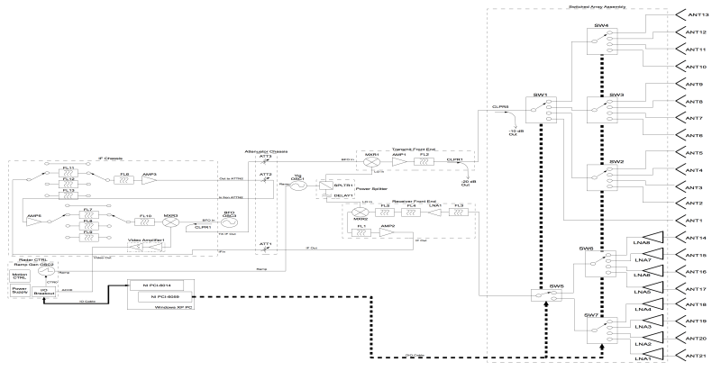

Figure 4: Example of a phased array radar system circuit